Ministero dell’Istruzione, dell’Università e della Ricerca |  | 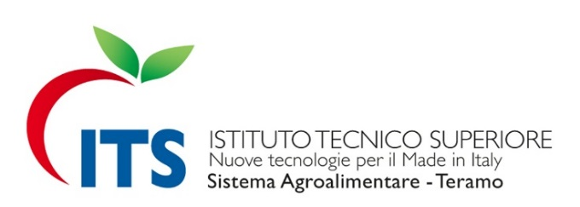

FONDAZIONE
“Istituto Tecnico Superiore Nuove Tecnologie per il Made in Italy, Sistema Agroalimentare e Sistema Moda” sede principale nella Provincia di Teramo e sede secondaria nella Provincia di Pescara.
Via A. De Benedictis, 1 - 64100 Teramo, Italy
WEB: www.itsagroalimentarete.it
E-MAIL: its.agroalimentare.te@pec.it – info@itsagroalimentarete.it

ISTITUTO DI RIFERIMENTO
IIS "Alessandrini – Marino - Forti" Via S. Marino, 12 - 64100 Teramo

ERASMUS POLICY STATEMENT

The ITS Foundation Agroalimentare of Teramo included in its politic strategy the participation to the Erasmus + Programme with the conviction that the mobility activities and the participation to international cooperation projects could facilitate the modernization and internationalization process and to increase the high education quality.
The main purpose of the mobility strategy is to promote the personal development, employability and the participation to the European world of work of the own students and facilitate knowledge and skills exchange among other educational sectors.
To induct this process, the Foundation has already deliberated to stipulate inter-institutional agreements with European HEIs, private and public bodies and EU enterprises, with whom ITS partners have already established relations, in order to experiment in 2015 the first contacts and the preparatory mobility toward the development of Erasmus + projects from 2016.
It has therefore, started the process to ensure the full recognition of study or traineeship activities among the diverse institutions forwarding to the implementation of the ECTS system choose by the Scientific and Technical Committee.
The ITS Foundation of Teramo offers training in the traditional Italian Agribusiness and in particular in the Abruzzi Region, it will choose foreign partners that work in the same sector to cooperate towards a series of aims as study activities, traineeship, follow-up meetings, conferences, work experience and good practices exchange, etc.
The partners will be homologous HEIs, which are holders of the Erasmus Charter for Higher Education (EACEA website), European Institutions and agribusiness enterprises, with whom the Foundation Partners (Polo d’Innovazione Agroalimentare Abruzzo, Confindustria Teramo, University of Teramo) already collaborate with and other subjects
The ITS Foundation intends to induct mobility experience of the students and the staff preferably in English language European Countries. In fact, the English language is object of evaluation during the selection of the students to proceed in the ITS courses and the English language continuous to be studied for all the duration of the formative period and for specific fields of study.
The principal participant of the ITS mobility activities will be students, teachers and administrative staff. The main aims of the ITS of Teramo strategy for the internationalization and mobility are:
- To enforce excellences, contributing to the development of training quality and promoting high results, through the innovation and reaching a European educational target.
- To contribute to the development of skills.
The ITS Foundation will entrust the realization of the international cooperation projects to its technical staff and external consultants, after the approval of the authorities of the Foundation (President, Members Council, Executive Committee and Scientific and Technical Committee).
In particular, technical staff will carry out:
- the organization of the international activities;
- the management of the projects developments;
- the management of the incoming and outgoing students, teachers, administrative staff and external consultants involved in the projects;
- Guard ship and recognition of the study and traineeship activities abroad.
The print office will sustain the promotion and diffusion of the projects.
The technical staff will wind even with the administrative office, that with the support of external consultants in the management and reporting of European projects, managing the financial aspects of the projects.
It enforced the support activities for students, creating a Student Office that will give the necessary information to students in mobility, in particular:
- room and board;
- transport, assurance, contacts;
- social and cultural activities;
- sport centers;
- Student associations.
The participation in projects that encourage strategic collaboration subsidized by the Erasmus + Programme which as an impact on the modernization and on the internationalization of the institutes and of the systems of high instruction of the partner countries will allow the ITS Foundation of Teramo to:
- Improve through the amplification of the horizon of reference and of resolution, the qualification level to allow the formation of the specialized technicians of which Europe is in need.
- Improve the quality of high instruction and the connection with the word of work and research developing and adapting educational paths that take into account specific competences and technological applications solicited by the world of work and of professions.
- Improve the professional, social and intercultural competences as well as the employment of their own holders of diploma thanks to the enlarge of the number of students who complete a period of study and formation abroad, of the mobility of teachers and staff as well as the intensification of the cultural changes and of the international cooperation among the institutions.
- Strengthen the quality of the teaching widening the knowledge of methods and teaching techniques comparing the good educational practices of the European countries.
- Improve the competences of the ITS staff incrementing the opportunities for their professional advancement and for their career.
- Evaluate the human resources boosting the motivation and satisfaction in one’s own daily work.
- Improve its own “governance” through a simplification of the authorities of management in the prospective of the constitution of the Professional Technical Poles that promotes the regional development thanks to the cooperation among the secondary technical and professional instruction, the high technical instruction and enterprises.
- Improve the disbursement of funds researching complementary source of private financing and public funding, calculating the real costs and orientating the expenses with the help of evaluation systems, of the results and concentrating the efforts on specific priority points.

